UI Design Requirements

Client: Acme Insurance Company

Document Prepared by: Rick Willcox

* Requirements brief

The aim of this project is to create a database for the ACME company to store customer information, the products they sell and also which products have been purchased by the customer. Furthermore, it will also be important to be able to add, delete, modify and search for customers and products using the GUI that will be designed. When searching it has been specified that the program must be able to search for at least two criteria’s and return results based on that search. The GUI will display all of this information in an easy to read and understandable format for the end user.

Due to having done a project previously for the ACME company I already know that they are operating on windows 10 and have the necessary requirements to run this application and a SQL Server.

The ACME Style Guide will be used throughout the entire application and every rule specified will be adhered to.

The application will be developed in the IDE Visual Studio using the programming language C#. Other programs used will be Microsoft SQL and in turn some SQL code will also be used.

The Program will retrieve information from the database using data queries such as SELECT, UPDATE, INSERT and DELETE. The information will be presented using tables inside the program window in an easy to read way. The program will be intuitive which will also ease in the learning of the program.

* Application content flow diagram

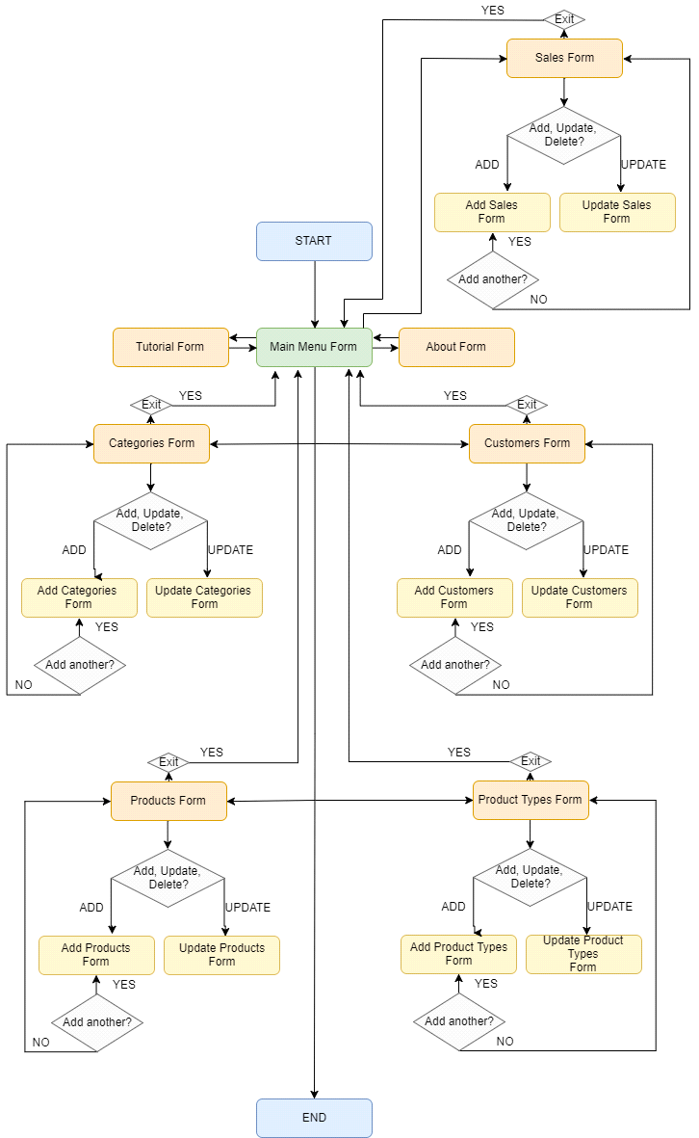

* Images of the Prototypes developed

Customers:

Main Customers Screen: 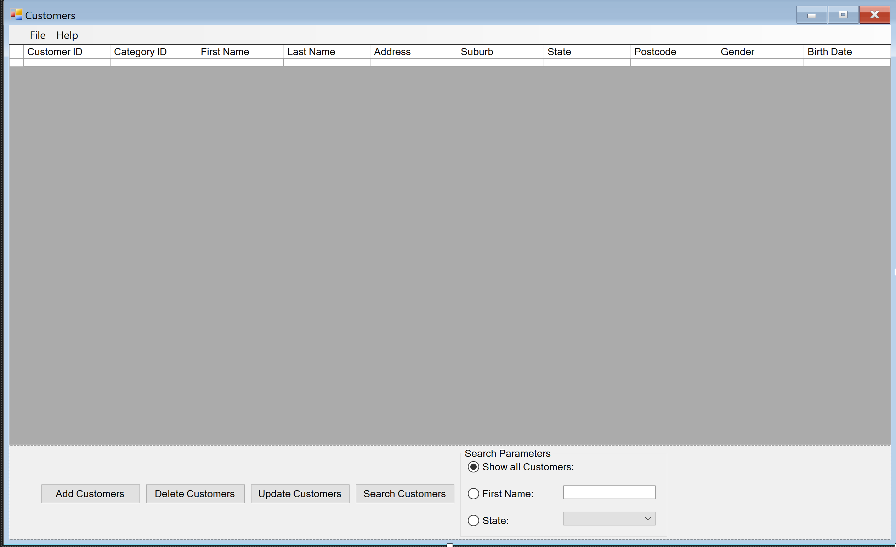

Customers Add Screen:

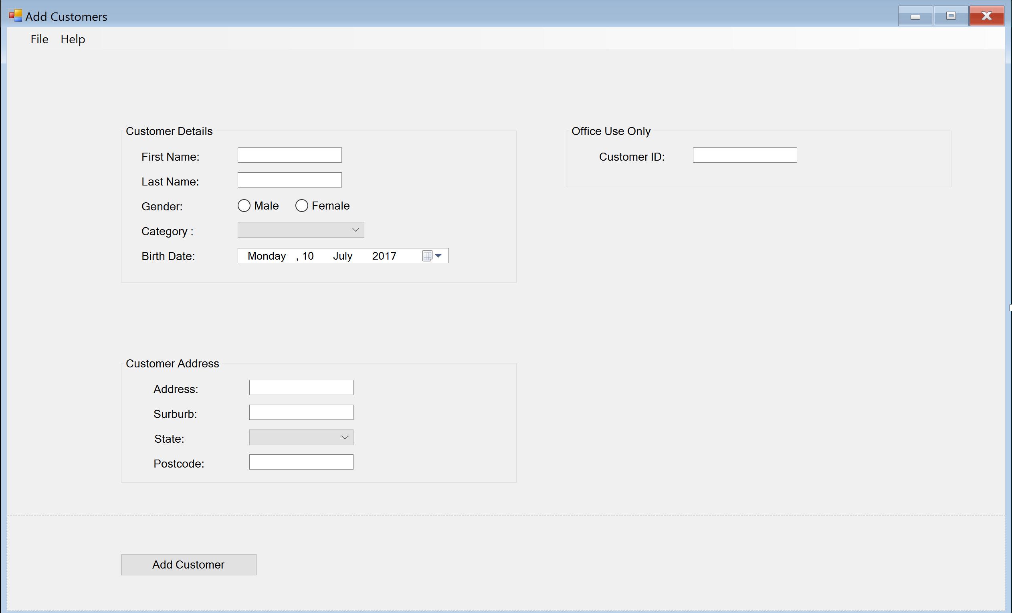

Customers Update Screen:

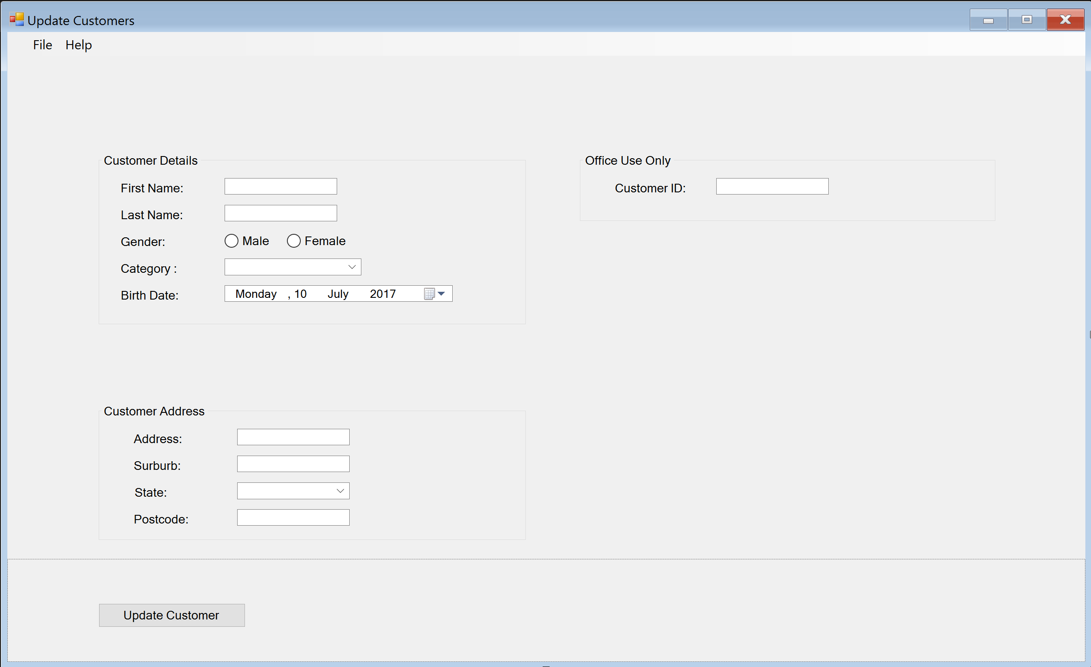

Sales:

Main Sales Screen:

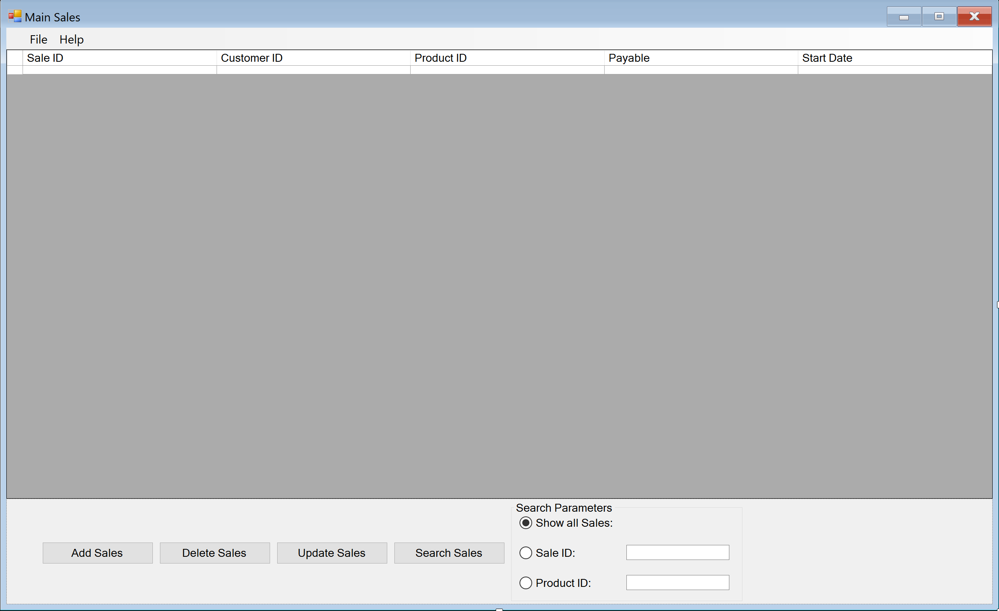

Sales Add Screen:

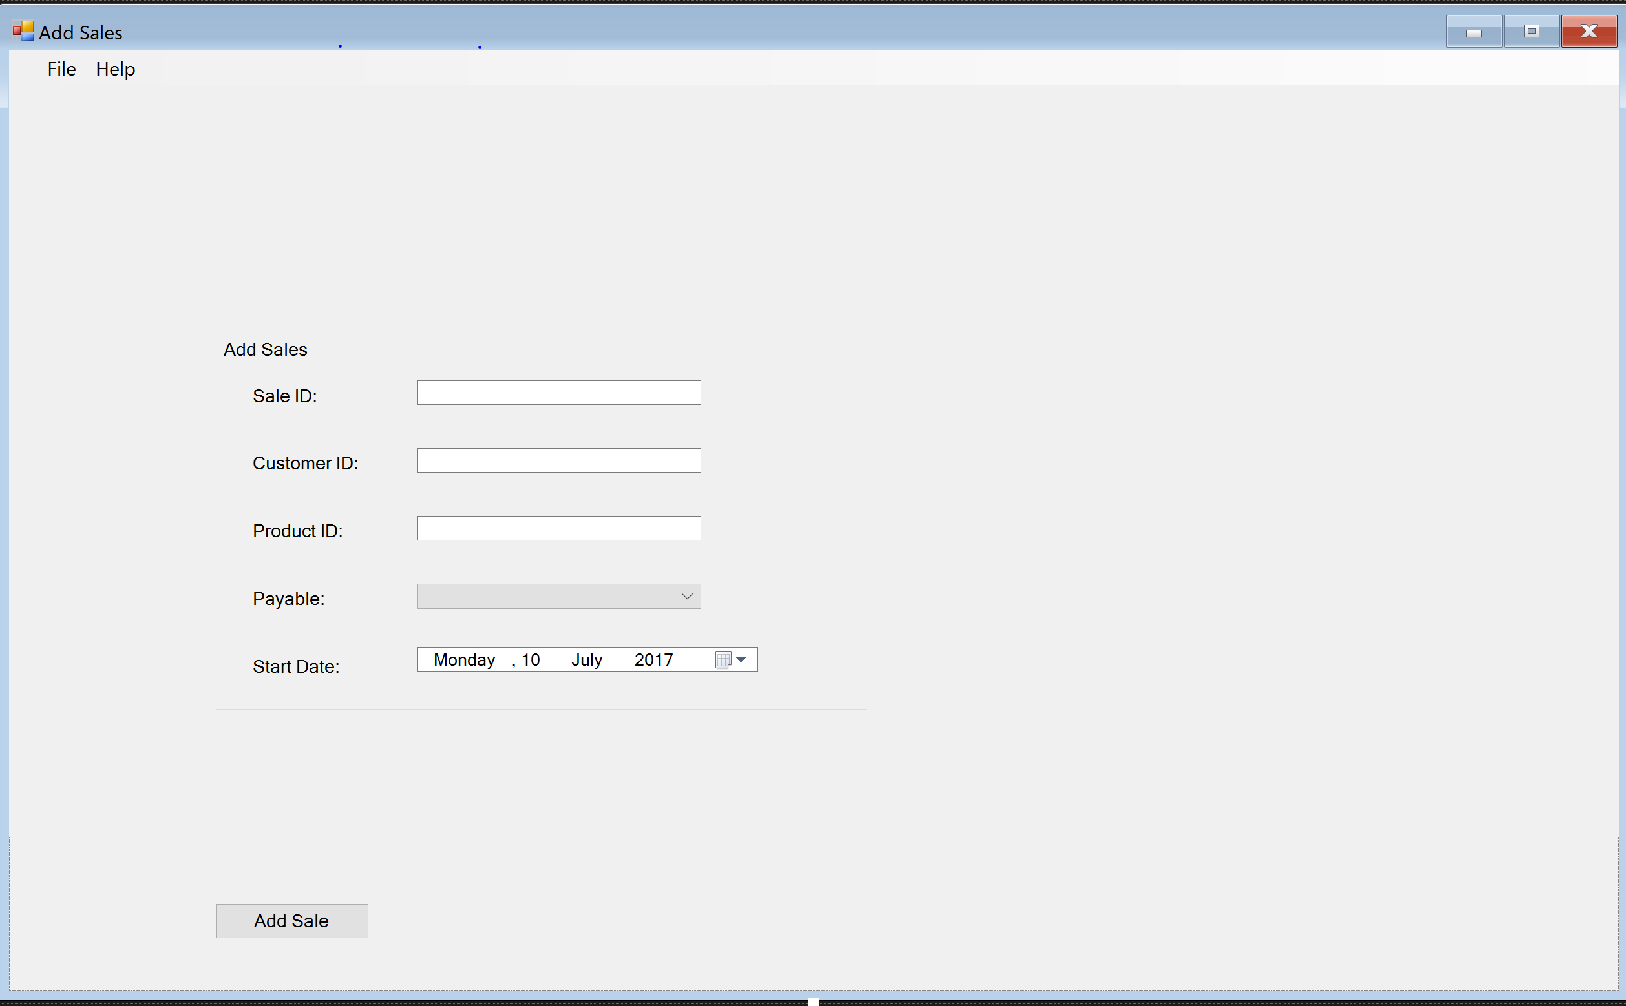

Sales Update Screen:

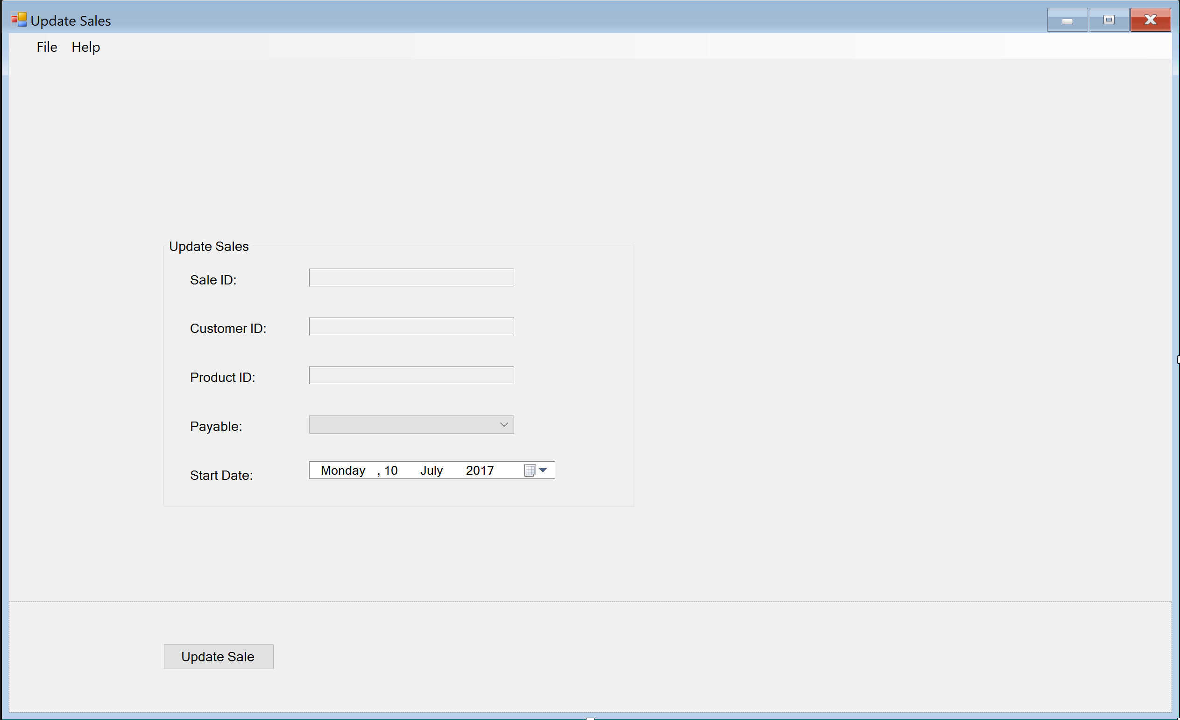

* Changes suggested by the client.

None The client was happy with the way the application looked as had no adjusts to make.

**MAINTENANCE:**

5.1 Form Name: Maintenance

Form Description: The first screen that is loaded when the program starts

Form: frmMaintenance

Form Components

|  |  |  |  |  |
| --- | --- | --- | --- | --- |
| No. | Column Names | Control | Property | Value |
| 1. | Customers | button | Name | btnCustomers |
| 2. | Products | button | Name | btnProducts |
| 3. | Sales | button | Name | btnSales |  |  |  |  |
| 4. | Product Types | button | Name | btnProductTypes |  |  |  |  |
| 5. | Categories | button | Name | btnCategories |  |  |  |  |
| 6. | Tutorial | button | Name | btnTutorial |  |  |  |  |
| 7. | About | button | Name | btnAbout |  |  |  |  |
| 8. | Menu | menuStrip | Name | msMenu |  |  |  |  |

Events Used on the form.

|  |  |  |
| --- | --- | --- |
| Component Name | Event | Description |
| btnCustomers | click | Open the main Customers Form |
| btnProducts | click | Open the main Products Form |
| btnSales | click | Open the main Sales Form |
| btnProductTypes | click | Open the main Product Types Form |
| btnCategories | click | Open the main Categories Form |
| btnTutorial | click | Open the Tutorial Form |
| btnAbout | click | Open the About Form |

**Customers:**

Form Name: Main Customers

Form Description: The first screen that is loaded when The Customers Button is clicked from the maintenance page. Displays all customers in the database.

Form: frmMainCustomers

Form Components

|  |  |  |  |  |
| --- | --- | --- | --- | --- |
| No. | Column Names | Control | Property | Value |
| 1. | Main Customers | Form | Name | frmMainCustomers |
| 2. | Add Customers | Button | Name | btnAddCustomers |
| 3. | Delete Customers | Button | Name | btnDeleteCustomers |
| 4. | Update Customers | Button | Name | btnUpdateCustomers |  |  |  |  |
| 5. | Search Customers | button | Name | btnSearchCustomers |  |  |  |  |
| 6. | Show All Customers | Radio button | Name | rbShowAll |  |  |  |  |
| 7. | First Name | Radio button | Name | rbSearchFirstName |  |  |  |  |
| 8. | State | Radio button | Name | rbSearchState |  |  |  |  |
| 9. | First Name | Text box | Name | txtFirstName |  |  |  |  |
| 10. | State | Combo Box | Name | cbState |  |  |  |  |
| 11. | Customers Table | Data Grid View | Name | dgvCustomers |  |  |  |  |

Events Used on the form.

|  |  |  |
| --- | --- | --- |
| Component Name | Event | Description |
| frmMainCustomers | load | Display all Customers from the Customers Table in the database by default. |
| btnAddCustomers | click | Open the Add Customers Form |
| btnDeleteCustomers | click | Delete the selected Customer |
| btnUpdateCustomers | click | Open the Update Customer Form |
| btnSearchCustomers | click | Displays only those results from the database that conform to the radio button selection |

Form Name: Add Customers

Form Description: The first screen that is loaded when The Add Customers Button is clicked from the Main Customers page. Shows input fields to fill in to add a new customer.

Form: frmAddCustomers

Form Components

|  |  |  |  |  |
| --- | --- | --- | --- | --- |
| No. | Column Names | Control | Property | Value |
| 1. | Customer Details Group Box | Group Box | Name | grpCustomerDetails |
| 2. | Customer Address Group Box | Group Box | Name | grpCustomerAddress |
| 3. | Office Use Only Group Box | Group Box | Name | grpOfficeUseOnly |
| 4. | Add Customer | Button | Name | btnAddCustomer |  |  |  |  |
| 5. | First Name | Label | Name | lblFirstName |  |  |  |  |
| 6. | First Name | Text Box | Name | txtFirstName |  |  |  |  |
| 7. | Last Name | Label | Name | lblLastName |  |  |  |  |
| 8. | Last Name | Text Box | Name | txtLastName |  |  |  |  |
| 9. | Gender | Label | Name | lblGender |  |  |  |  |
| 10. | Gender Male | Radio Button | Name | rbGenderMale |  |  |  |  |
| 11. | Gender Female | Radio Button | Name | rbGenderFemale |  |  |  |  |
| 12. | Category | Label | Name | lblCategory |  |  |  |  |
| 13. | Category | Combo Box | Name | cbCategory |  |  |  |  |
| 14. | Birthdate | Label | Name | lblBirthDate |  |  |  |  |
| 15. | Birthdate | Date Picker | Name | dtBirthDate |  |  |  |  |
| 16. | Address | Label | Name | lblAddress |  |  |  |  |
| 17. | Address | Text Box | Name | txtAddress |  |  |  |  |
| 18. | Suburb | Label | Name | lblSuburb |  |  |  |  |
| 19. | Suburb | Text Box | Name | txtSuburb |  |  |  |  |
| 20. | State | Label | Name | lblState |  |  |  |  |
| 21. | State | Combo Box | Name | cbState |  |  |  |  |
| 22. | Postcode | Label | Name | lblPostcode |  |  |  |  |
| 23. | Postcode | Text Box | Name | txtPostcode |  |  |  |  |
| 24. | Customer ID | Label | Name | lblCustomerID |  |  |  |  |
| 25. | Customer ID | Text Box | Name | txtCustomerID |  |  |  |  |

Events Used on the form.

|  |  |  |
| --- | --- | --- |
| Component Name | Event | Description |
| btnAddCustomers | click | Adds the customer into the database |

Form Name: Update Customers

Form Description: The first screen that is loaded when The Update Customers Button is clicked from the Main Customers page. The input fields are already filled in to the selected Customer details.

Form: frmUpdateCustomers

Form Components

|  |  |  |  |  |
| --- | --- | --- | --- | --- |
| No. | Column Names | Control | Property | Value |
| 1. | Customer Details Group Box | Group Box | Name | grpCustomerDetails |
| 2. | Customer Address Group Box | Group Box | Name | grpCustomerAddress |
| 3. | Office Use Only Group Box | Group Box | Name | grpOfficeUseOnly |
| 4. | Update Customer | Button | Name | btnUpdateCustomer |  |  |  |  |
| 5. | First Name | Label | Name | lblFirstName |  |  |  |  |
| 6. | First Name | Text Box | Name | txtFirstName |  |  |  |  |
| 7. | Last Name | Label | Name | lblLastName |  |  |  |  |
| 8. | Last Name | Text Box | Name | txtLastName |  |  |  |  |
| 9. | Gender | Label | Name | lblGender |  |  |  |  |
| 10. | Gender Male | Radio Button | Name | rbGenderMale |  |  |  |  |
| 11. | Gender Female | Radio Button | Name | rbGenderFemale |  |  |  |  |
| 12. | Category | Label | Name | lblCategory |  |  |  |  |
| 13. | Category | Combo Box | Name | cbCategory |  |  |  |  |
| 14. | Birthdate | Label | Name | lblBirthDate |  |  |  |  |
| 15. | Birthdate | Date Picker | Name | dtBirthDate |  |  |  |  |
| 16. | Address | Label | Name | lblAddress |  |  |  |  |
| 17. | Address | Text Box | Name | txtAddress |  |  |  |  |
| 18. | Suburb | Label | Name | lblSuburb |  |  |  |  |
| 19. | Suburb | Text Box | Name | txtSuburb |  |  |  |  |
| 20. | State | Label | Name | lblState |  |  |  |  |
| 21. | State | Combo Box | Name | cbState |  |  |  |  |
| 22. | Postcode | Label | Name | lblPostcode |  |  |  |  |
| 23. | Postcode | Text Box | Name | txtPostcode |  |  |  |  |
| 24. | Customer ID | Label | Name | lblCustomerID |  |  |  |  |
| 25. | Customer ID | Text Box | Name | txtCustomerID |  |  |  |  |

Events Used on the form.

|  |  |  |
| --- | --- | --- |
| Component Name | Event | Description |
| frmUpdateCustomers | load | Loads the selected customer information from the main customers page into the relevant fields. |
| btnUpdateCustomers | click | A the customer into the database |

**Products:**

Form Name: Main Products

Form Description: The first screen that is loaded when The Products Button is clicked from the maintenance page. Displays all Products in the database.

Form: frmMainProducts

Form Components

|  |  |  |  |  |
| --- | --- | --- | --- | --- |
| No. | Column Names | Control | Property | Value |
| 1. | Main Products | Form | Name | frmMainProducts |
| 2. | Add Products | Button | Name | btnAddProducts |
| 3. | Delete Products | Button | Name | btnDeleteProducts |
| 4. | Update Products | Button | Name | btnUpdateProducts |  |  |  |  |
| 5. | Search Products | button | Name | btnSearchProducts |  |  |  |  |
| 6. | Show All Products | Radio button | Name | rbShowAll |  |  |  |  |
| 7. | Product Name | Radio button | Name | rbSearchProductName |  |  |  |  |
| 8. | State | Radio button | Name | rbSearchYearlyPremium |  |  |  |  |
| 9. | First Name | Text box | Name | txtFirstName |  |  |  |  |
| 10. | Yearly Premium | Text box | Name | txtYearlyPremium |  |  |  |  |
| 11. | Operator | Combo Box | Name | cbOperator |  |  |  |  |
| 12. | Products Table | Data Grid View | Name | dgv Products |  |  |  |  |

Events Used on the form.

|  |  |  |
| --- | --- | --- |
| Component Name | Event | Description |
| frmMainProducts | load | Display all Products from the Products Table in the database by default. |
| btnAddProducts | click | Open the Add Products Form |
| btnDeleteProducts | click | Delete the selected Product |
| btnUpdateProducts | click | Open the Update Products Form |
| btnSearchProducts | click | Displays only those results from the database that conform to the radio button selection |

Form Name: Add Products

Form Description: The first screen that is loaded when The Add Products Button is clicked from the Main Products page. Shows input fields to fill in to Update a new Product.

Form: frmAddProducts

Form Components

|  |  |  |  |  |
| --- | --- | --- | --- | --- |
| No. | Column Names | Control | Property | Value |
| 1. | Product Group Box | Group Box | Name | grpProducts |
| 2. | Add Product | Button | Name | btnAddProduct |  |  |  |  |
| 3. | Product Type | Label | Name | lblProductType |  |  |  |  |
| 4. | Product Type | Combo Box | Name | txtProductType |  |  |  |  |
| 5. | Product Name | Label | Name | lblProductName |  |  |  |  |
| 6. | Product Name | Text Box | Name | txtProductNam |  |  |  |  |
| 7. | Yearly Premium | Label | Name | lblYearlyPremium |  |  |  |  |
| 8. | Yearly Premium | Text Box | Name | txtYearlyPremium |  |  |  |  |

Events Used on the form.

|  |  |  |
| --- | --- | --- |
| Component Name | Event | Description |
| btnAddProduct | click | Adds the product into the database |

Form Name: Update Products

Form Description: The first screen that is loaded when The Update Products Button is clicked from the Main Products page. Shows input fields to fill in to Update a Product. Has the fields already filled out to the selected database entry.

Form: frmUpdateProducts

Form Components

|  |  |  |  |  |
| --- | --- | --- | --- | --- |
| No. | Column Names | Control | Property | Value |
| 1. | Product Group Box | Group Box | Name | grpProducts |
| 2. | Update Product | Button | Name | btnUpdateProduct |  |  |  |  |
| 3. | Product Type | Label | Name | lblProductType |  |  |  |  |
| 4. | Product Type | Combo Box | Name | txtProductType |  |  |  |  |
| 5. | Product Name | Label | Name | lblProductName |  |  |  |  |
| 6. | Product Name | Text Box | Name | txtProductNam |  |  |  |  |
| 7. | Yearly Premium | Label | Name | lblYearlyPremium |  |  |  |  |
| 8. | Yearly Premium | Text Box | Name | txtYearlyPremium |  |  |  |  |

Events Used on the form.

|  |  |  |
| --- | --- | --- |
| Component Name | Event | Description |
| frmUpdateProducts | Load | Loads the selected product information into the relevant fields on the form |
| btnUpdateProduct | click | Updates the product into the database |

|  |  |  |  |
| --- | --- | --- | --- |
|  |  |  |  |

**Product Types:**

Form Name: Main Product Types

Form Description: The first screen that is loaded when The Product Types Button is clicked from the maintenance page. Displays all Product Types in the database.

Form: frmMainProductTypes

Form Components

|  |  |  |  |  |
| --- | --- | --- | --- | --- |
| No. | Column Names | Control | Property | Value |
| 1. | Main Product Types | Form | Name | frmMainProductTypes |
| 2. | Add Product Types | Button | Name | btnAddProductTypes |
| 3. | Delete Product Types | Button | Name | btnDeleteProductTypes |
| 4. | Update Product Types | Button | Name | btnUpdateProductTypes |  |  |  |  |
| 5. | Search Product Types | button | Name | btnSearchProductTypes |  |  |  |  |
| 6. | Show All Product Types | Radio button | Name | rbShowAll |  |  |  |  |
| 7. | Product Type ID | Radio button | Name | rbSearchProductTypeID |  |  |  |  |
| 8. | Product Type | Radio button | Name | rbSearchProductType |  |  |  |  |
| 9. | Product Type ID | Text box | Name | txtProductTypeID |  |  |  |  |
| 10. | Product Type | Text | Name | txtProductType |  |  |  |  |
| 11. | Product Types Table | Data Grid View | Name | dgvProductTypes |  |  |  |  |

Events Used on the form.

|  |  |  |
| --- | --- | --- |
| Component Name | Event | Description |
| frmMainProductTypes | load | Display all Product Types from the Product Types Table in the database by default. |
| btnAddProductTypes | click | Open the Add Product Types Form |
| btnDeleteProductTypes | click | Delete the selected Product Types |
| btnUpdateProductTypes | click | Open the Update Product Types Form |
| btnSearchProductTypes | click | Displays only those results from the database from search parameters. |

Form Name: Add Product Types

Form Description: The first screen that is loaded when The Add Product Types

Button is clicked from the Main Product Types page. Shows input fields to fill in to Add a new Product Type.

Form: frmAddProductTypes

Form Components

|  |  |  |  |  |  |  |  |  |
| --- | --- | --- | --- | --- | --- | --- | --- | --- |
| No. | | Column Names | | Control | | Property | | Value |
| 1. | | Product Types Group Box | | Group Box | | Name | | grpProductTypes |
| 2. | | Add Product Types | | Button | | Name | | btnAddProductTypes |  |  |  |  |
| 3. | | Product Type ID | | Label | | Name | | lblProductTypeID |  |  |  |  |
| 4. | | Product Type ID | | Text Box | | Name | | txtProductTypeID |  |  |  |  |
| 5. | | Product Type | | Label | | Name | | lblProductType |  |  |  |  |
| 6. | | Product Type | | Text Box | | Name | | txtProductType |  |  |  |  |
|  |  | |  | |  | |
|  |  | |  | |  | |

Events Used on the form.

|  |  |  |
| --- | --- | --- |
| Component Name | Event | Description |
| btnAddProductType | click | Adds the product type into the database |

Form Name: Update Product Types

Form Description: The first screen that is loaded when The Update Product Types

Button is clicked from the Main Product Types page. Has the input fields filled out with the selected product type.

Form: frmUpdateProductTypes

Form Components

|  |  |  |  |  |  |  |  |  |
| --- | --- | --- | --- | --- | --- | --- | --- | --- |
| No. | | Column Names | | Control | | Property | | Value |
| 1. | | Product Types Group Box | | Group Box | | Name | | grpProductTypes |
| 2. | | Update Product Types | | Button | | Name | | btnUpdateProductTypes |  |  |  |  |
| 3. | | Product Type ID | | Label | | Name | | lblProductTypeID |  |  |  |  |
| 4. | | Product Type ID | | Text Box | | Name | | txtProductTypeID |  |  |  |  |
| 5. | | Product Type | | Label | | Name | | lblProductType |  |  |  |  |
| 6. | | Product Type | | Text Box | | Name | | txtProductType |  |  |  |  |
|  |  | |  | |  | |
|  |  | |  | |  | |

Events Used on the form.

|  |  |  |
| --- | --- | --- |
| Component Name | Event | Description |
| frmUpdateProductTypes | Load | Loads the selected product Type into the relevant fields. |
| btnUpdateProductType | click | Updates the product type into the database |

**SALES:**

Form Name: Main Sales

Form Description: The first screen that is loaded when The Sales Button is clicked from the maintenance page. Displays all Sales in the database.

Form: frmMainSales

Form Components

|  |  |  |  |  |
| --- | --- | --- | --- | --- |
| No. | Column Names | Control | Property | Value |
| 1. | Main Sales | Form | Name | frmMainSales |
| 2. | Add Sales | Button | Name | btnAddSales |
| 3. | Delete Sales | Button | Name | btnDeleteSales |
| 4. | Update Sales | Button | Name | btnUpdateSales |  |  |  |  |
| 5. | Search Sales | button | Name | btnSearchSales |  |  |  |  |
| 6. | Show All Sales | Radio button | Name | rbShowAll |  |  |  |  |
| 7. | Sale ID | Radio button | Name | rbSearchSaleID |  |  |  |  |
| 8. | Product ID | Radio button | Name | rbSearchProductID |  |  |  |  |
| 9. | Sale ID | Text box | Name | txtSaleID |  |  |  |  |
| 10. | Product ID | Text box | Name | txtProductID |  |  |  |  |
| 11. | Operator | Combo Box | Name | cbOperator |  |  |  |  |
| 12. | Sales Table | Data Grid View | Name | dgvSales |  |  |  |  |

Events Used on the form.

|  |  |  |
| --- | --- | --- |
| Component Name | Event | Description |
| frmMainSales | load | Display all Sales from the Sales Table in the database by default. |
| btnAddSales | click | Open the Add Sales Form |
| btnDeleteSales | click | Delete the selected Product |
| btnUpdateSales | click | Open the Update Sales Form |
| btnSearchSales | click | Displays only those results from the database that conform to the radio button selection |

Form Name: Add Sales

Form Description: The first screen that is loaded when The Add Sales Button is clicked from the Main Sales page. Shows input fields to fill in to add a new Sale.

Form: frmAddSales

Form Components

|  |  |  |  |  |
| --- | --- | --- | --- | --- |
| No. | Column Names | Control | Property | Value |
| 1. | Sale Details Group Box | Group Box | Name | grpSaleDetails |
| 2. | Add Sale | Button | Name | btnAddSale |  |  |  |  |
| 3. | Sale ID | Label | Name | lblSaleID |  |  |  |  |
| 4. | Sale ID | Text Box | Name | txtSaleID |  |  |  |  |
| 5. | Product ID | Label | Name | lblProductID |  |  |  |  |
| 6. | Product ID | Text Box | Name | txtProductID |  |  |  |  |
| 7. | Customer ID | Label | Name | lblCustomerID |  |  |  |  |
| 8. | Customer ID | Text Box | Name | txtCustomerID |  |  |  |  |
| 9. | Payable | Label | Name | lblPayable |  |  |  |  |
| 10. | Payable | Combo Box | Name | cbPayable |  |  |  |  |
| 11. | Start Date | Label | Name | lblStartDate |  |  |  |  |
| 12. | Start Date | Date Picker | Name | dtStartDate |  |  |  |  |

Events Used on the form.

|  |  |  |
| --- | --- | --- |
| Component Name | Event | Description |
| btnAddSales | click | Adds the Sale into the database |

Form Name: Update Sales

Form Description: The first screen that is loaded when The Update Sales Button is clicked from the Main Sales page. Shows input fields to fill in to update a new Sale.

Form: frmUpdateSales

Form Components

|  |  |  |  |  |
| --- | --- | --- | --- | --- |
| No. | Column Names | Control | Property | Value |
| 1. | Sale Details Group Box | Group Box | Name | grpSaleDetails |
| 2. | Update Sale | Button | Name | btnUpdateSale |  |  |  |  |
| 3. | Sale ID | Label | Name | lblSaleID |  |  |  |  |
| 4. | Sale ID | Text Box | Name | txtSaleID |  |  |  |  |
| 5. | Product ID | Label | Name | lblProductID |  |  |  |  |
| 6. | Product ID | Text Box | Name | txtProductID |  |  |  |  |
| 7. | Customer ID | Label | Name | lblCustomerID |  |  |  |  |
| 8. | Customer ID | Text Box | Name | txtCustomerID |  |  |  |  |
| 9. | Payable | Label | Name | lblPayable |  |  |  |  |
| 10. | Payable | Combo Box | Name | cbPayable |  |  |  |  |
| 11. | Start Date | Label | Name | lblStartDate |  |  |  |  |
| 12. | Start Date | Date Picker | Name | dtStartDate |  |  |  |  |

Events Used on the form.

|  |  |  |
| --- | --- | --- |
| Component Name | Event | Description |
| frmUpdateSales | load | Fills in the current form with the selected sale details to be updated. |
| btnUpdateSales | click | Updates the Sale into the database |

**CATEGORIES:**

Form Name: Main Categories

Form Description: The first screen that is loaded when The Categories Button is clicked from the maintenance page. Displays all Categories in the database.

Form: frmMainCategories

Form Components

|  |  |  |  |  |
| --- | --- | --- | --- | --- |
| No. | Column Names | Control | Property | Value |
| 1. | Main Categories | Form | Name | frmMainCategories |
| 2. | Add Categories | Button | Name | btnAddCategories |
| 3. | Delete Categories | Button | Name | btnDeleteCategories |
| 4. | Update Categories | Button | Name | btnUpdateCategories |  |  |  |  |
| 5. | Search Categories | button | Name | btnSearchCategories |  |  |  |  |
| 6. | Show All Categories | Radio button | Name | rbShowAll |  |  |  |  |
| 7. | Sale ID | Radio button | Name | rbSearchSaleID |  |  |  |  |
| 8. | Product ID | Radio button | Name | rbSearchProductID |  |  |  |  |
| 9. | Sale ID | Text box | Name | txtSaleID |  |  |  |  |
| 10. | Product ID | Text box | Name | txtProductID |  |  |  |  |
| 11. | Operator | Combo Box | Name | cbOperator |  |  |  |  |
| 12. | Categories Table | Data Grid View | Name | dgvCategories |  |  |  |  |

Events Used on the form.

|  |  |  |
| --- | --- | --- |
| Component Name | Event | Description |
| frmMainCategories | load | Display all Categories from the Categories Table in the database by default. |
| btnAddCategories | click | Open the Add Categories Form |
| btnDeleteCategories | click | Delete the selected Product |
| btnUpdateProducts | click | Open the Update Categories Form |
| btnSearchProducts | click | Displays only those results from the database that conform to the radio button selection |

Form Name: Add Categories

Form Description: The first screen that is loaded when The Add Categories Button is clicked from the Main Categories page. Shows input fields to fill in to add a new Category.

Form: frmAddCategories

Form Components

|  |  |  |  |  |
| --- | --- | --- | --- | --- |
| No. | Column Names | Control | Property | Value |
| 1. | Category Details Group Box | Group Box | Name | grpCategoryDetails |
| 2. | Add Category | Button | Name | btnAddCategory |  |  |  |  |
| 3. | Category ID | Label | Name | lblCategoryID |  |  |  |  |
| 4. | Category ID | Text Box | Name | txtCategoryID |  |  |  |  |
| 5. | Category | Label | Name | lblCategory |  |  |  |  |
| 6. | Category | Text Box | Name | txtCategory |  |  |  |  |

Events Used on the form.

|  |  |  |
| --- | --- | --- |
| Component Name | Event | Description |
| btnAddCategories | click | Adds the category into the database |

Form Name: Update Categories

Form Description: The first screen that is loaded when The Update Categories Button is clicked from the Main Categories page. The fields will already be filled in with the selected categories details.

Form: frmUpdateCategories

Form Components

|  |  |  |  |  |
| --- | --- | --- | --- | --- |
| No. | Column Names | Control | Property | Value |
| 1. | Category Details Group Box | Group Box | Name | grpCategoryDetails |
| 2. | Update Category | Button | Name | btnUpdateCategory |  |  |  |  |
| 3. | Category ID | Label | Name | lblCategoryID |  |  |  |  |
| 4. | Category ID | Text Box | Name | txtCategoryID |  |  |  |  |
| 5. | Category | Label | Name | lblCategory |  |  |  |  |
| 6. | Category | Text Box | Name | txtCategory |  |  |  |  |

Events Used on the form.

|  |  |  |
| --- | --- | --- |
| Component Name | Event | Description |
| frmUpdateCategories | Load | Loads the selected categories details into the relevant fields on this form |
| btnUpdateCategories | click | Updates the category into the database |

**TUTORIAL:**

1 Form Name: Tutorial

Form Description: The screen that is loaded when the tutorial button is clicked from the maintenance screen.

Form: frmTutorial

Form Components

|  |  |  |  |  |  |  |  |
| --- | --- | --- | --- | --- | --- | --- | --- |
| No. | Column Names | | Control | | Property | | Value |
| 1. | Yotube Tutorial | | Shockwave Player | | Name | | movTutorial |
|  | |  |  |  | |
|  | |  |  |  | |
|  | |  |  |  | |
|  | |  |  |  | |
|  | |  |  |  | |

Events Used on the form.

|  |  |  |
| --- | --- | --- |
| Component Name | Event | Description |
| movTutorial | Load | Plays the Video tutorial for the program. |

**ABOUT:**

1 Form Name: About

Form Description: The screen that is loaded when the About button is clicked from the maintenance screen.

Form: frm About

Form Components

|  |  |  |  |  |  |  |  |
| --- | --- | --- | --- | --- | --- | --- | --- |
| No. | Column Names | | Control | | Property | | Value |
| 1. | Heading | | Label | | Name | | lblAbout |
|  | |  |  |  | |
|  | |  |  |  | |
|  | |  |  |  | |
|  | |  |  |  | |
|  | |  |  |  | |

Events Used on the form.

|  |  |  |
| --- | --- | --- |
| Component Name | Event | Description |
| None | None | None |

**Are you sure you wish to delete entry screenshot. Same for every table:**

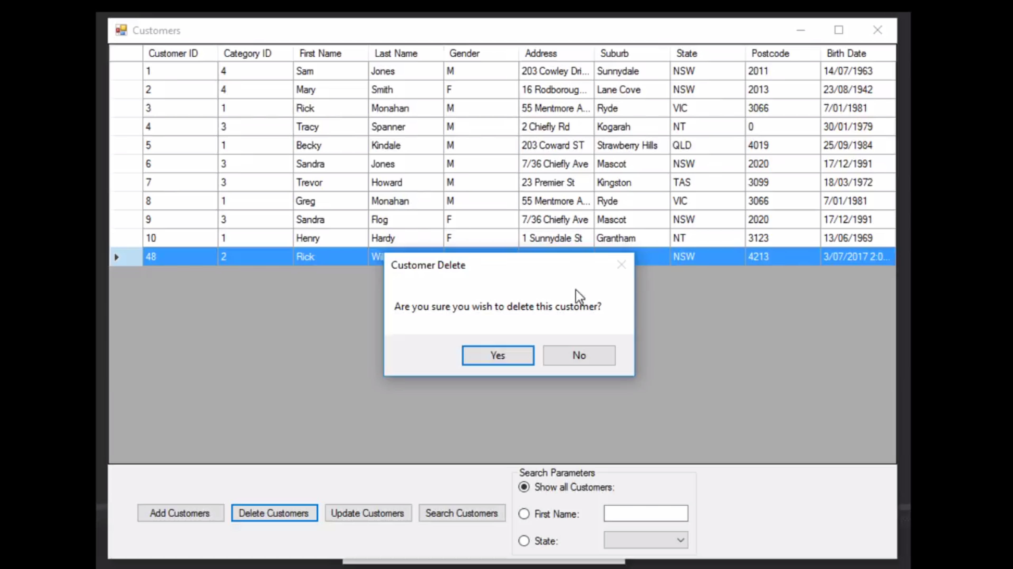

Approval

Name: _____________________________ Date: ___/___/______